Menu 4

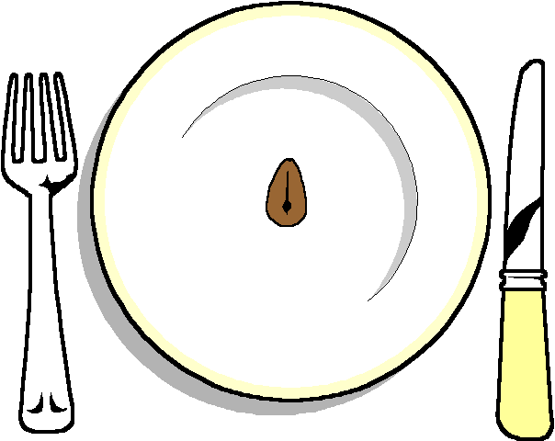

Half Lobster Thermodor

******

Fillet of Beef
On a rosti potato
With a Dijon and tarragon sauce
Crispy leeks on top
Selection of Seasonal Vegetables

******

Individual Rich Chocolate Tart

******
Cheese and Biscuits

******

Coffee and chocolates

